Test Case: tc001_SPX_Dev5_Crear_Requisicion_Spot_Tipo_Cobro_CC
Step 1 - Enter username and password and click to button Enter : Credentials Entered
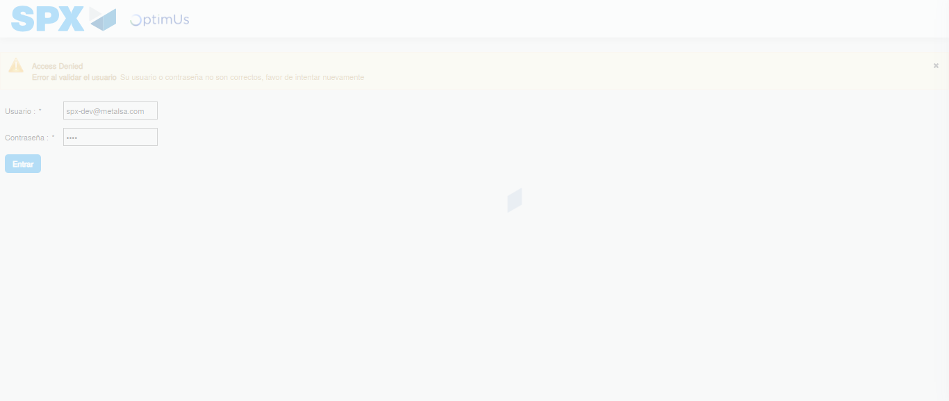Image file-name: QC_Testing-tc001_SPX_Dev5_Crear_Requisicion_Spot_Tipo_Cobro_CC-1788297590473

Step 2 - Select to UEN and Access to Spot Buy Requisitions : UEN Correctly selected and Correct access
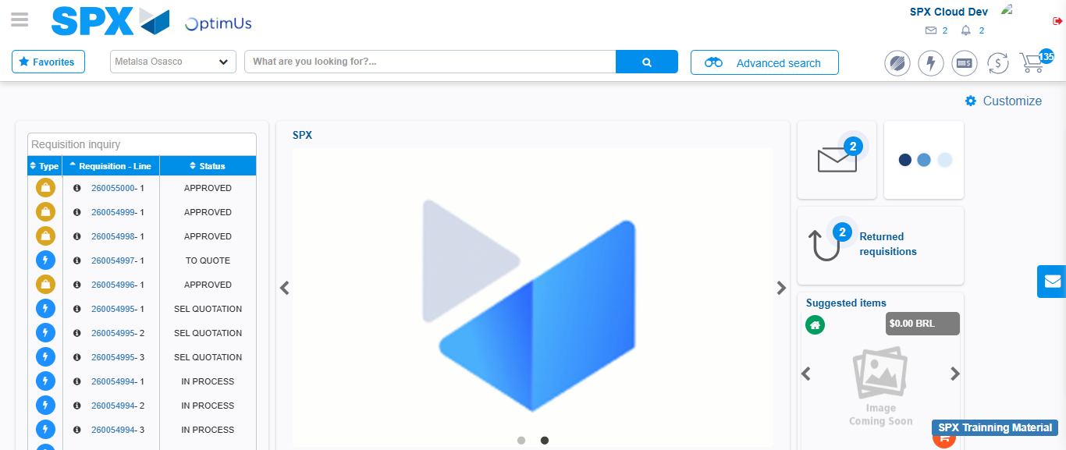Image file-name: QC_Testing-tc001_SPX_Dev5_Crear_Requisicion_Spot_Tipo_Cobro_CC-1788297616534

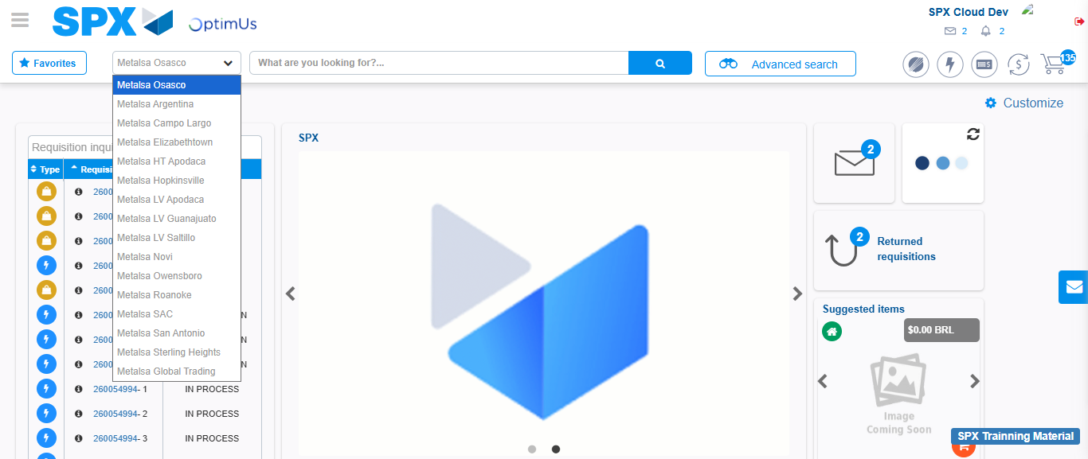Image file-name: QC_Testing-tc001_SPX_Dev5_Crear_Requisicion_Spot_Tipo_Cobro_CC-1788297617143

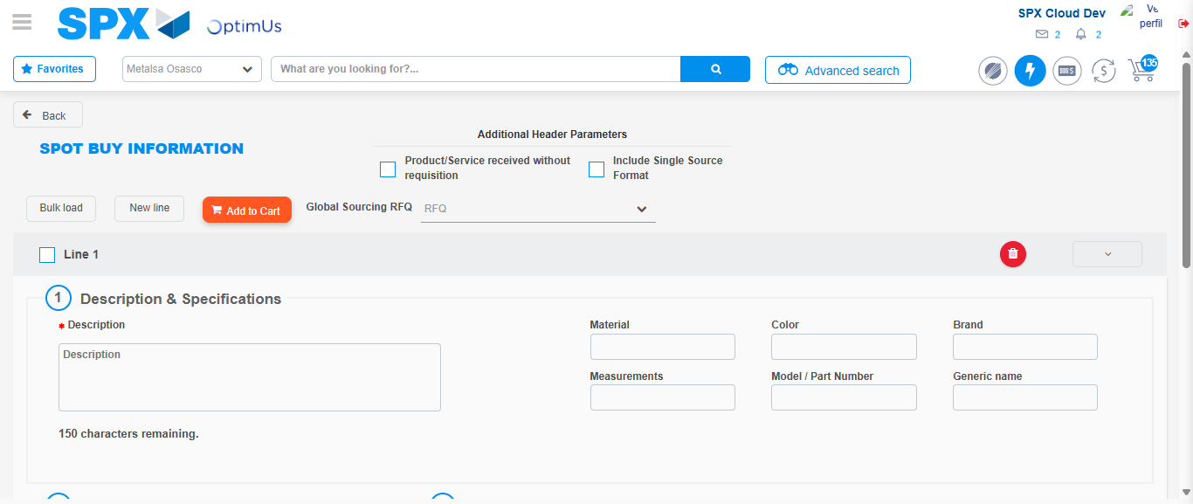Image file-name: QC_Testing-tc001_SPX_Dev5_Crear_Requisicion_Spot_Tipo_Cobro_CC-1788297640416

Step 3 - Data Capture Spot Buy Requisition : Data captured correctly
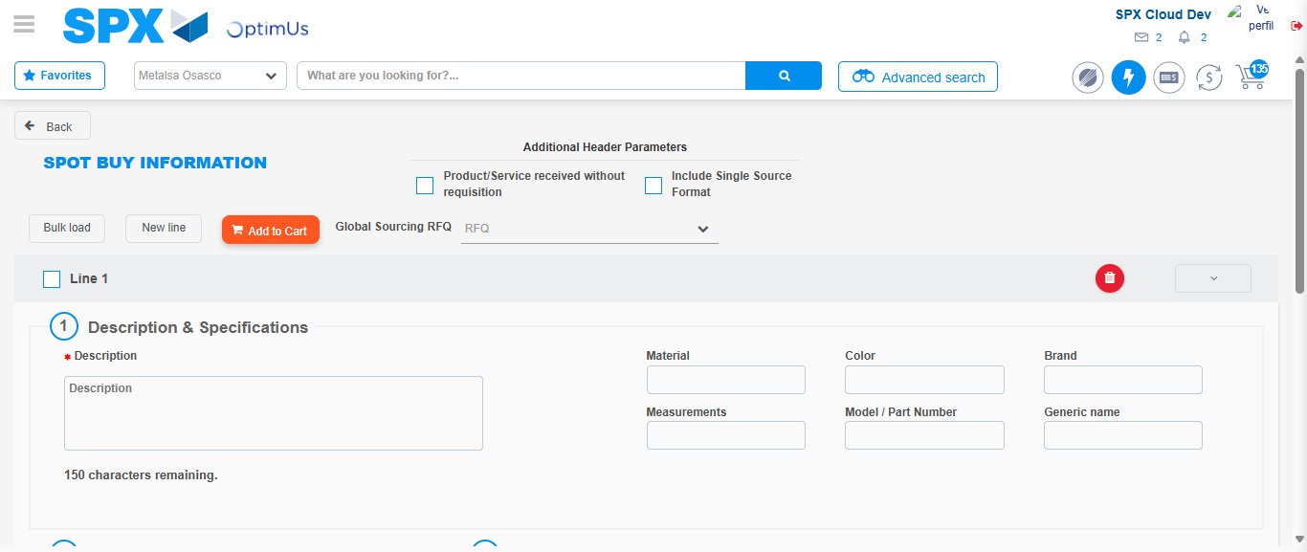Image file-name: QC_Testing-tc001_SPX_Dev5_Crear_Requisicion_Spot_Tipo_Cobro_CC-1788297640660

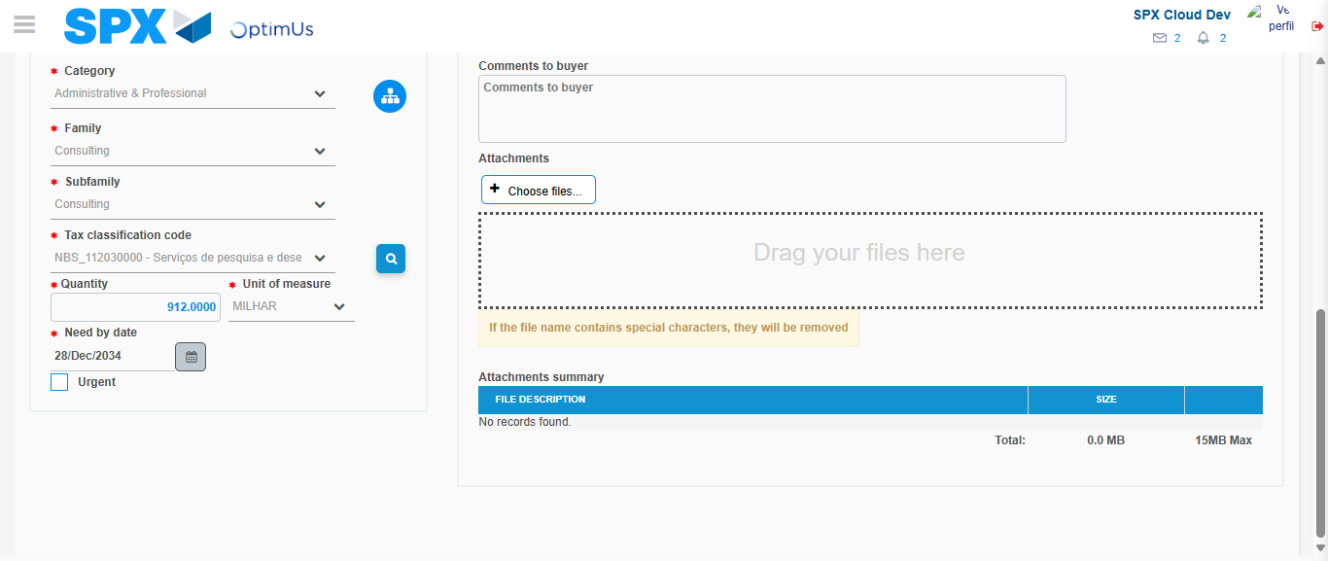Image file-name: QC_Testing-tc001_SPX_Dev5_Crear_Requisicion_Spot_Tipo_Cobro_CC-1788297656179

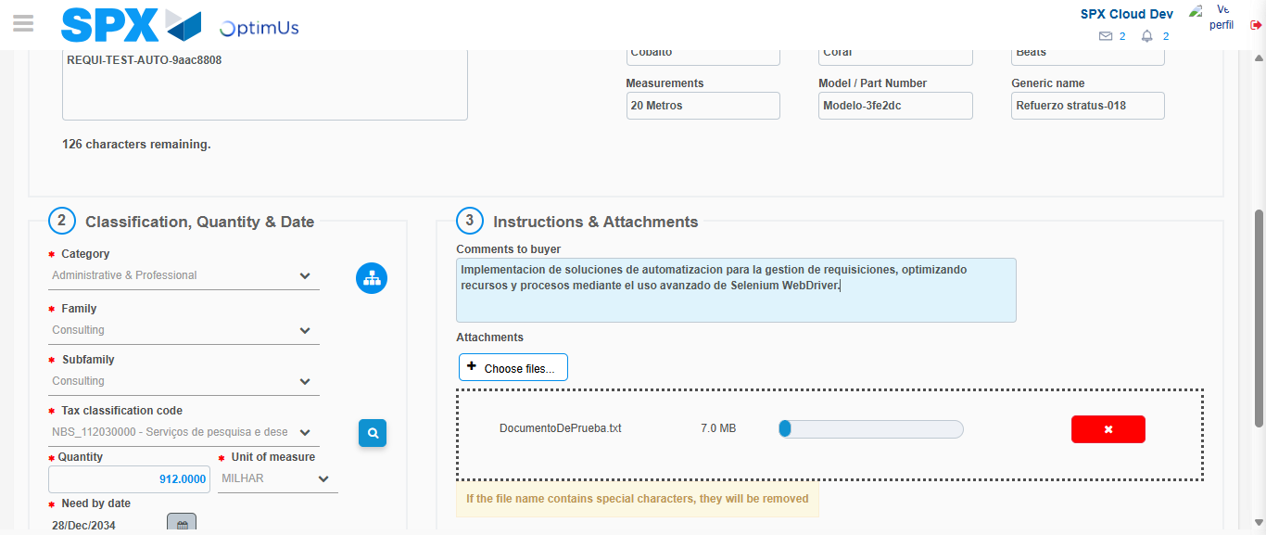Image file-name: QC_Testing-tc001_SPX_Dev5_Crear_Requisicion_Spot_Tipo_Cobro_CC-1788297657005

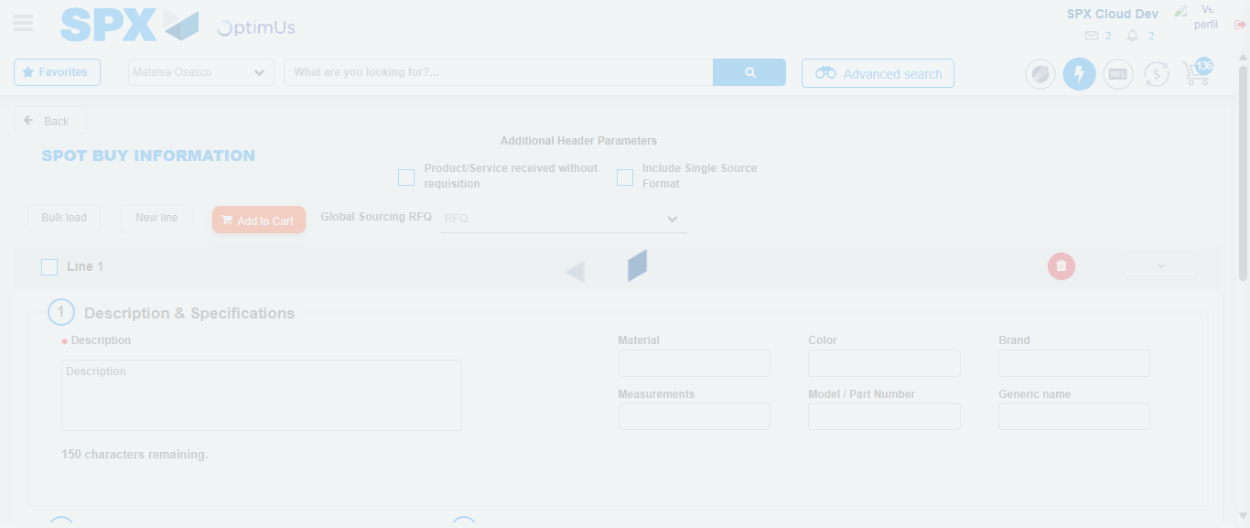Image file-name: QC_Testing-tc001_SPX_Dev5_Crear_Requisicion_Spot_Tipo_Cobro_CC-1788297663150

Step 7 - Return to Main Page SPX : Return to Main Page SPX
Image file-name: QC_Testing-tc001_SPX_Dev5_Crear_Requisicion_Spot_Tipo_Cobro_CC-1788297616534

Image file-name: QC_Testing-tc001_SPX_Dev5_Crear_Requisicion_Spot_Tipo_Cobro_CC-1788297617143

Image file-name: QC_Testing-tc001_SPX_Dev5_Crear_Requisicion_Spot_Tipo_Cobro_CC-1788297640416

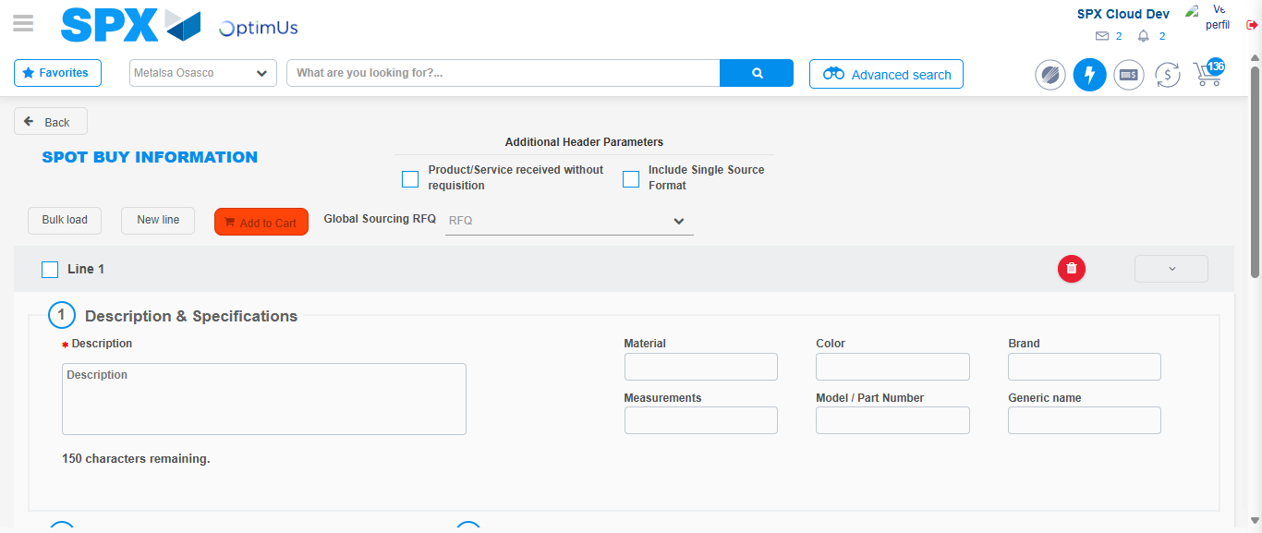Image file-name: QC_Testing-tc001_SPX_Dev5_Crear_Requisicion_Spot_Tipo_Cobro_CC-1788297665462

Image file-name: QC_Testing-tc001_SPX_Dev5_Crear_Requisicion_Spot_Tipo_Cobro_CC-1788297665654

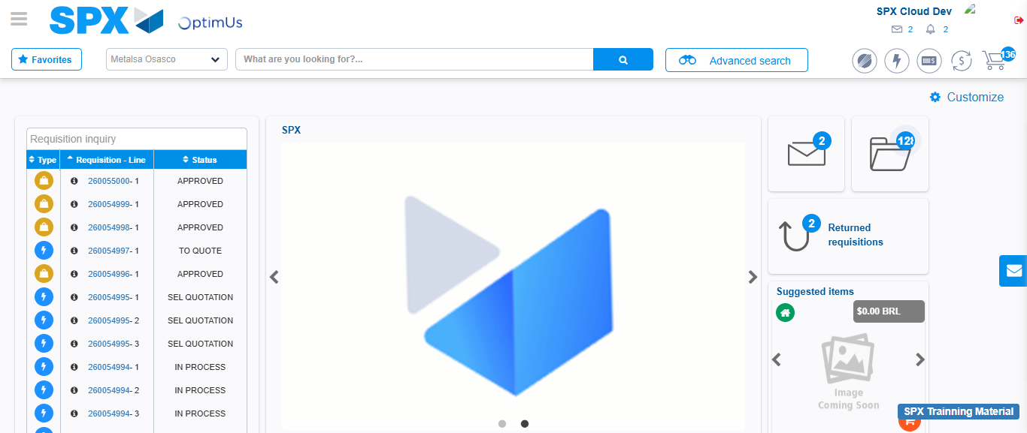Image file-name: QC_Testing-tc001_SPX_Dev5_Crear_Requisicion_Spot_Tipo_Cobro_CC-1788297686810

Step 8 - Log Out : Log Out SPX
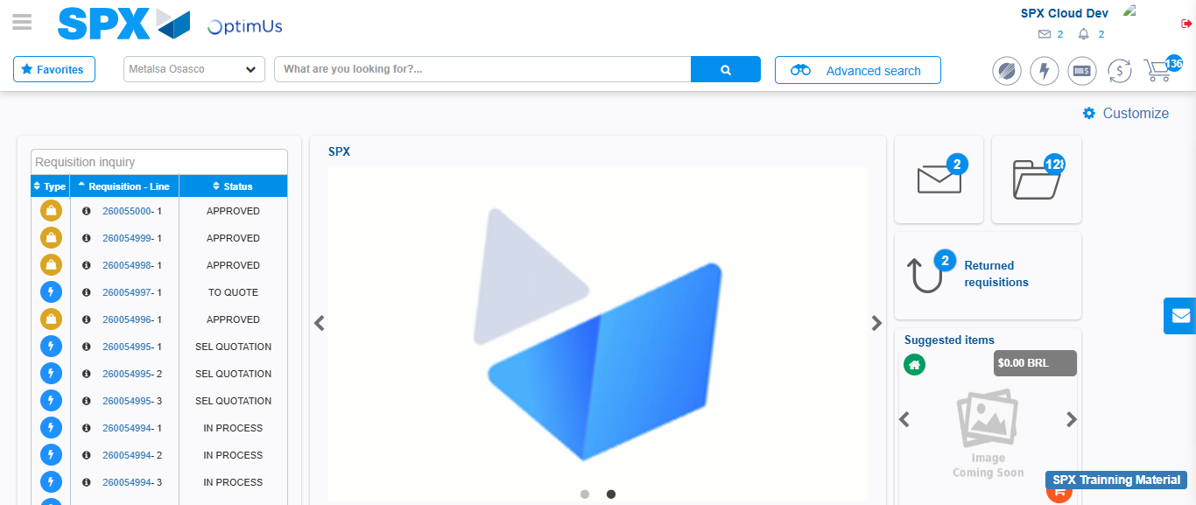Image file-name: QC_Testing-tc001_SPX_Dev5_Crear_Requisicion_Spot_Tipo_Cobro_CC-1788297687157

